Institución: ISPI N°9233 “Estudios Superiores de Santa Fe” Carrera: DESARROLLO DE SOFTWARE.
Cátedra: INGLÉS TÉCNICO I Profesor: CUELLO, Federico Lucas.
Examen Parcial: N°2 Año Lectivo: 2021
Name: Date:

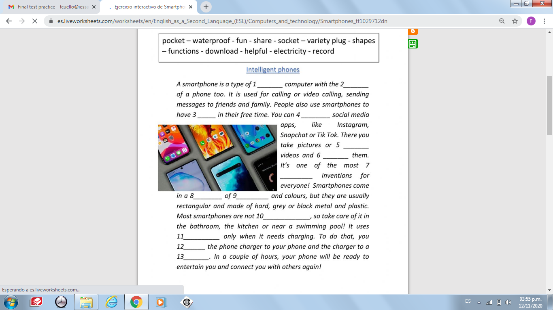
- Read the text and fill in the blanks

1-
2-
3-
4-
5-
6-
7-
8-
9-
10-
11-
12-
13-

- Fill in the blanks with SIMPLE PRESENT:

- ………………………… (he / go) to work by bus everyday.
- She ………………………. (not / like) football.
- He …………………….. (write) a letter to his pen-friend every month.
- I ……………………………. (not / like) spaghetti.
- My mother usually …………………. (cook) dinner in the evening.
- ……………………………. (you / want) a pizza?

- Write the verbs into the PRESENT CONTINUOUS.
1. The baby …………………………. (sleep) now.
2. Mary ………………………….. (listen) to music now.
3. I …………………. (drink) tea now.
4. We ………………………. (go) to the disco tonight.
5. They …………………………….. (watch) TV now.

- Make the PAST SIMPLE, positive, negative or question:
1. I _________________ (not / drink) any beer last night.
2. She _________________ (get on) the bus in the centre of the city.
3. What time _________________ (he / get up) yesterday?
4. Where _________________ (you / get off) the train?
5. I _________________ (not / change) trains at Victoria.
6. We _________________ (wake up) very late.
7. What _________________ (he / give) his mother for Christmas?
8. I _________________ (receive) £300 when my uncle _________________ (die).
9. We _________________ (not / use) the computer last night.
10. _________________ (she / make) good coffee?
11. They _________________ (live) in Paris.

VOCABULARY: ASSISTIVE TECHNOLOGY
- Match the words with the definitions:
VISUAL SEACH ENGINE ………….. TEXT TO SPEECH ………….. VOICE RECOGNITION ………….
SCREEN MAGNIFICATION SOFTWARE ……………. Automatic transcription software …………

- Allows any electronic text that can be highlighted to be read aloud by a computer or mobile device.
- Enlarges the text and graphics on a computer screen or mobile device
- Allows a computer or enabled hand held device to be trained in how you speak, and once trained, to write down everything you dictate into any active textbox.
- This software converts audio into text.
- Displays a picture of a page rather than the text headings or written content of a webpage.

